**Step 1:**

For creating a project, suppose vue/react with vite,

npm install vite@latest react-crash-2024

**Step 2**: port change korte hobe, from the project folder find **vite.config.js**, then change the port like this code snippet,

import { defineConfig } from "vite";

import react from "@vitejs/plugin-react";

// https://vitejs.dev/config/

export default defineConfig({

  plugins: [react()],

  server: {

    port: 3000,

  },

});

Port change kore just 3000 e switch kore newa holo

Learning purpose e ja kora holo, **src->assets** er under e **app.css** ke remove kore dewa holo and **app.jsx** ke ekdm clean kore fela holo.

Then ekta extension install kora holo, it gives easy snippets to generate components,  
  


For an example, on the **App.jsx** empty page, type, ‘**rafce’** then press tab. It will create a react component automatically.

**Index.css** er shob remove kore dewa holo.

**Step 3: Tailwind Setup**

<https://tailwindcss.com/docs/guides/vite>

* Run this command, For tailwind configuration,  
  npm install -D tailwindcss postcss autoprefixer

npx tailwindcss init -p

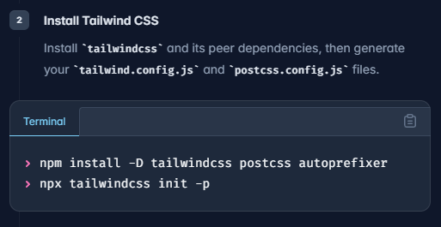

From **tailwind.config.js,**

/** @type {import('tailwindcss').Config} */

export default {

  content: ["./index.html", "./src/**/*.{js,ts,jsx,tsx}"],

  theme: {

    extend: {

      fontFamily: {

        sans: ["Roboto", "sans-sarif"],

      },

      gridTemplateColumns: {

        "70:40": "70% 28%",

      },

    },

  },

  plugins: [],

};

According to tutorial

* Font-damily add kora hoise
* gridTemplateColumns : The left column will be 70% and the right column will be 30%

Then docs e step wise follow kore jete hobe for **Tailwind** setup.